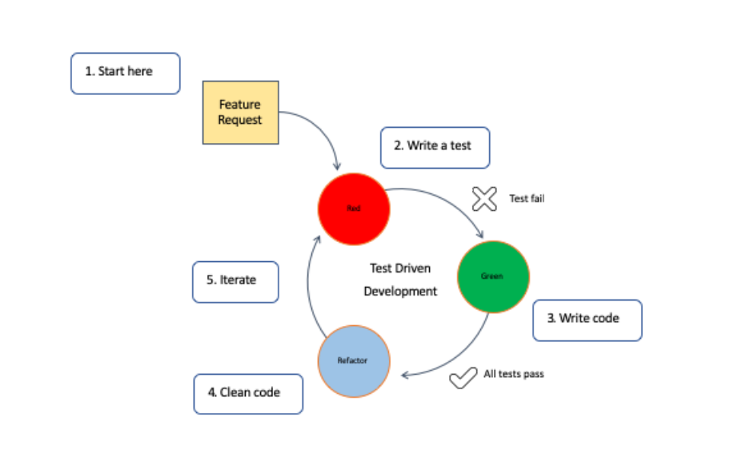

Test-Driven Development (TDD)

Approach: In TDD, developers write tests for the functionality they want before they write the actual code to implement that functionality. They start with writing a test that will fail since there's no code yet. Then, they write code to make that test pass. After that, they refactor the code to make it cleaner and more efficient.

Benefits:

Ensures code is thoroughly tested from the beginning.

Encourages better code design as developers think about the requirements first.

Helps in catching bugs early in the development process.

Suitability: TDD is suitable for projects where requirements are well-understood and unlikely to change frequently. It's also helpful in projects where code quality and reliability are crucial.

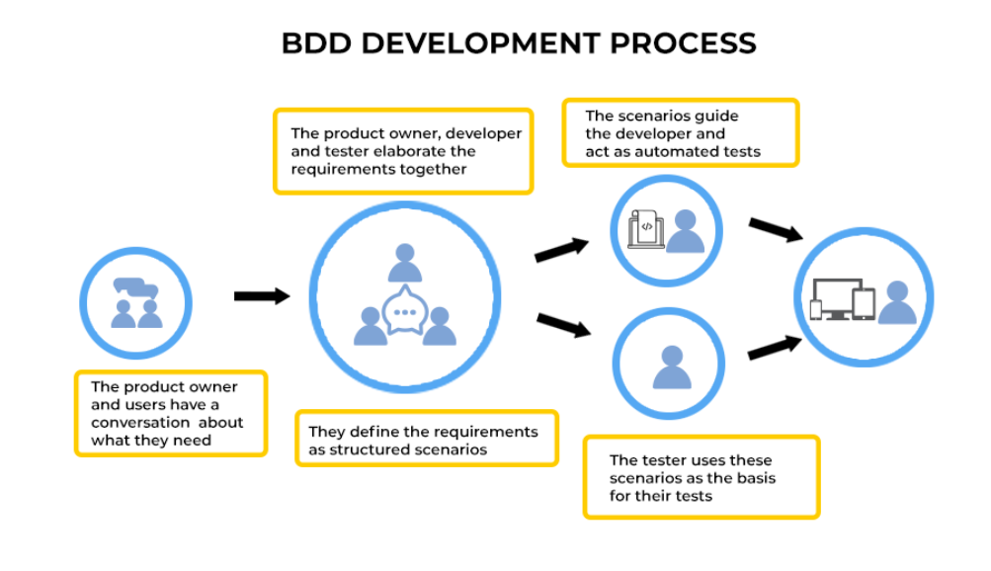

Behavior-Driven Development (BDD)

Approach: BDD extends TDD by focusing on the behavior or outcomes of the software. It uses a more natural language to define tests called "scenarios" or "specifications". These scenarios are written in collaboration with stakeholders to ensure that the software meets their expectations.

Benefits:

Promotes collaboration between developers, testers, and business stakeholders.

Improves communication by using a common language understood by all parties.

Helps in developing software that aligns closely with business goals.

Suitability: BDD is suitable for projects with complex business logic or where requirements are likely to change frequently. It's also beneficial for projects where there's a need for clear communication between technical and non-technical stakeholders.

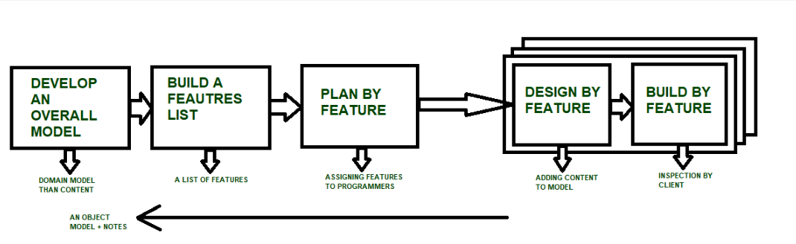

Feature-Driven Development (FDD)

Approach: FDD is focused on breaking down the development process into smaller, manageable features. It starts with creating an overall model of the system, then features are developed iteratively, one by one. Each feature goes through a series of steps including domain walkthrough, design, and implementation.

Benefits:

Emphasizes on delivering tangible features incrementally.

Provides clear guidelines for development teams on how to proceed.

Allows for parallel development of different features by different teams.

Suitability: FDD is suitable for large-scale projects with a lot of developers where managing complexity is crucial. It's also useful in projects where there's a need for frequent releases and continuous integration.